Bifidobacterium Deficiency in United States Infants Drives Prevalent Gut Dysbiosis – Supplementary Information

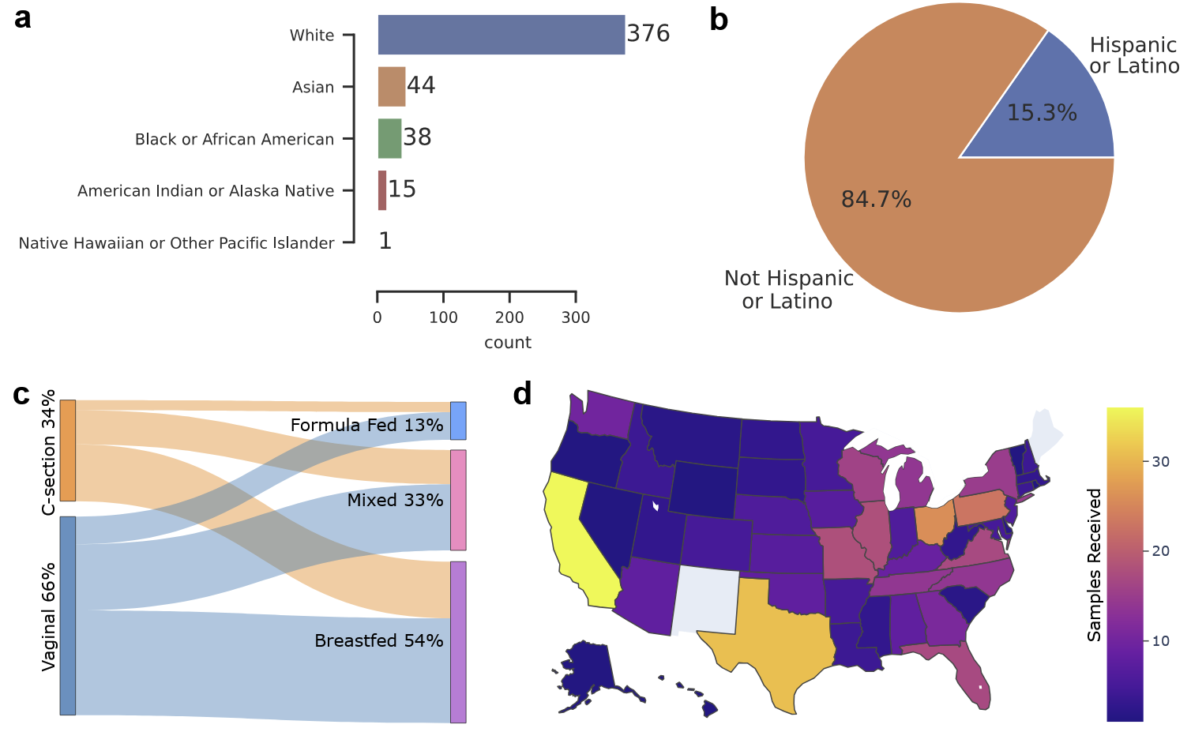
Supplementary Figure 1: My Baby Biome Participant Summary. a. Number of participants reporting each of 5 races. Many participants reported more than one race; therefore, each bar represents the number of participants containing that race in their reporting, and the total of all the bars exceeds 412. b. Pie chart showing the fraction of participants reporting Hispanic or Latino ethnicity. c. Summary statistics of fractions of infants by birth mode and initial feeding mode (vaginal birth n=273, C-section n = 139, breastfed n=222, mixed feeding n=138, formula fed n=52). d. Choropleth showing the number of infant stool samples obtained from each state in the United States.
Supplementary Table 1 – Prevalence and Abundance of 20 Most Abundant Species
Species | Fraction of samples containing¹ | Mean relative abundance² | Mean relative abundance when present³
Bifidobacterium breve | 0.373786 | 0.111373 | 0.297959
Bifidobacterium bifidum | 0.162621 | 0.043552 | 0.267814
Bifidobacterium infantis⁴ | 0.077670 | 0.016615 | 0.213924
Bifidobacterium longum⁵ | 0.645631 | 0.137215 | 0.212529
Bacteroides fragilis | 0.133495 | 0.026871 | 0.201288
Bifidobacterium pseudocatenulatum | 0.148058 | 0.022819 | 0.154124
Phocaeicola vulgatus | 0.293689 | 0.034421 | 0.117203
Escherichia coli⁶ | 0.691748 | 0.074412 | 0.107572
Ruminococcus_B gnavus | 0.283981 | 0.029911 | 0.105328
Klebsiella pneumoniae | 0.157767 | 0.015145 | 0.095997
Erysipelatoclostridium ramosum | 0.247573 | 0.019234 | 0.077690
Clostridium_P perfringens | 0.143204 | 0.010092 | 0.070475
Bacteroides caccae | 0.140777 | 0.009855 | 0.070003
Parabacteroides distasonis | 0.201456 | 0.013322 | 0.066128
Bacteroides uniformis | 0.165049 | 0.009658 | 0.058516
Veillonella parvula_A | 0.174757 | 0.007162 | 0.040981
Clostridium_AQ innocuum | 0.155340 | 0.006236 | 0.040142
Enterococcus faecalis | 0.250000 | 0.007599 | 0.030395
Streptococcus sp001556435 | 0.143204 | 0.003616 | 0.025251
Flavonifractor plautii | 0.223301 | 0.005093 | 0.022807
Streptococcus sp000187445 | 0.182039 | 0.003892 | 0.021381
Eggerthella lenta | 0.233010 | 0.002924 | 0.012550
1 Fraction of the 412 samples containing species at greater than 0.5%
2 Mean abundance of all samples, including those with less than 0.5%
3 Mean abundance of only samples containing greater than 0.5% of the species
4 B. infantis is not in the top 20 for occurrence in samples, but when it is in a sample it tends to have a high relative abundance, placing it as the 10th highest mean relative abundance
5 B. longum has the highest mean relative abundance
6 E. coli is the most prevalent species

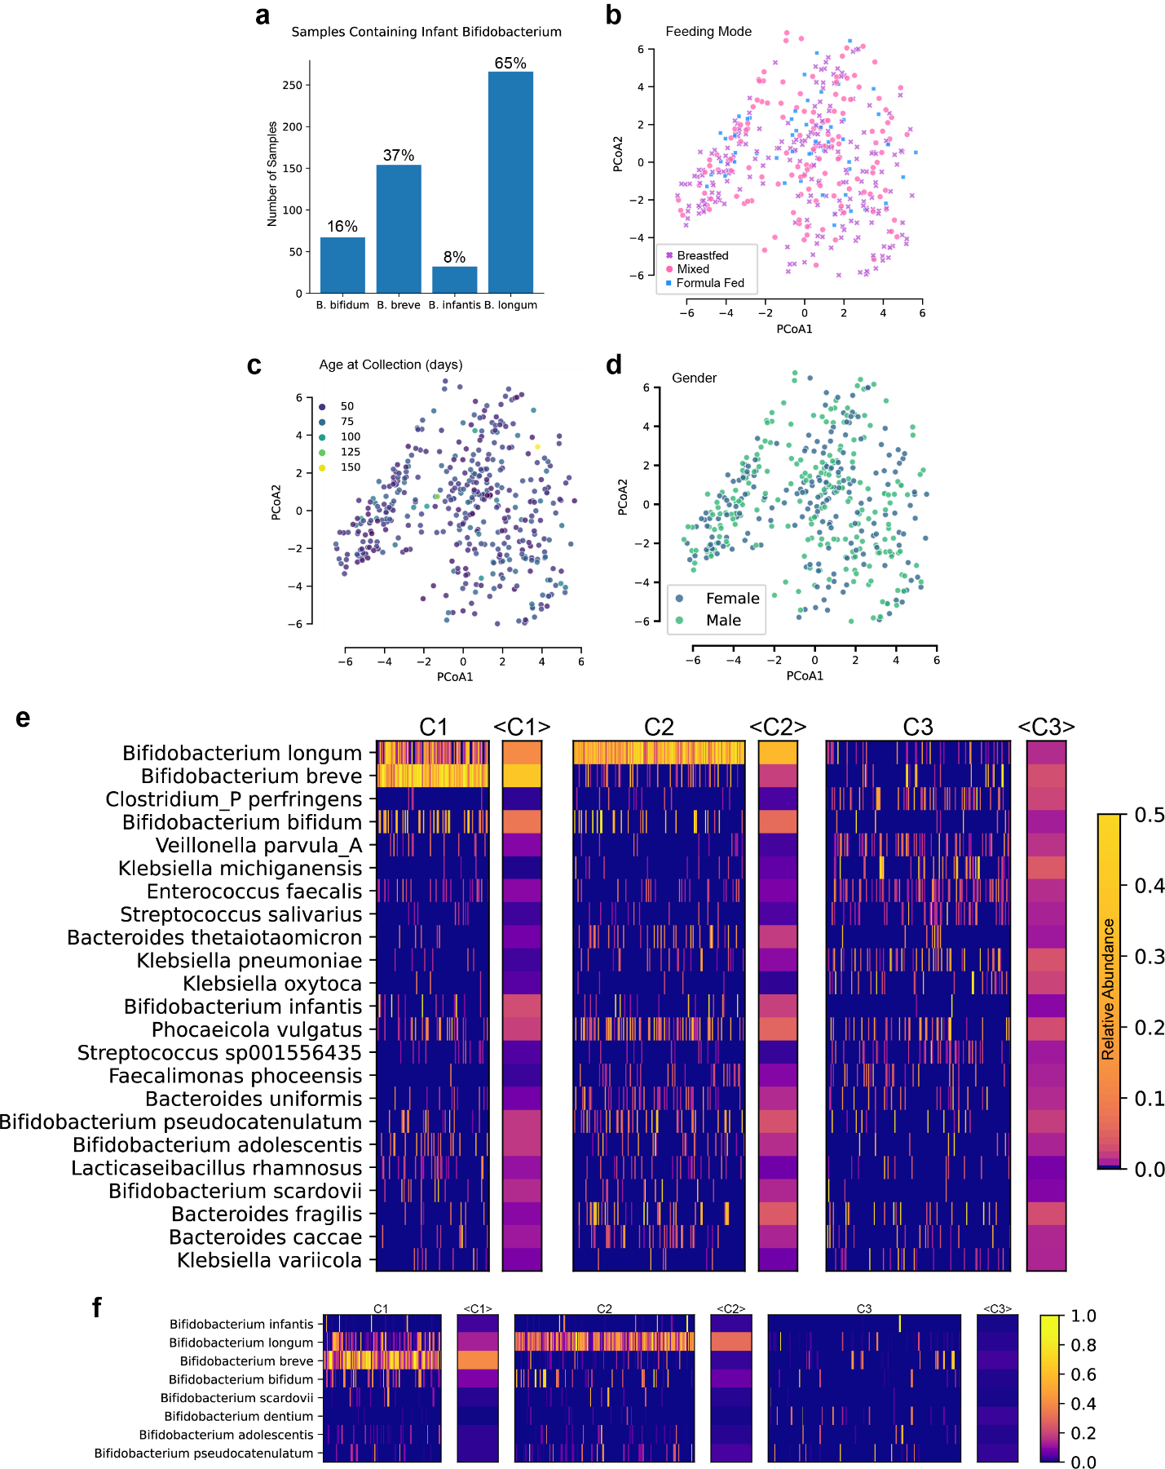
Supplementary Figure 2: Demographics and Prevalence by Birth Mode. a. Fraction of samples (n=412) containing each of the four infant Bifidobacterium species. Only 8% of samples have B. infantis above 0.5% relative abundance. b. Aitchison distance PCoA showing feeding mode. c. Aitchison distance PCoA highlighting infant ages at time of sample collection, illustrating that age is not a dominating factor of gut microbiome composition within this limited age range. d. Aitchison distance PCoA showing gender. e. Relative abundances for 23 distinguishing species (rows) across samples (columns) grouped by DMM cluster, with cluster means in adjacent columns. Only species that are present above 1% in at least 20 samples are shown (Kruskal-Wallis test, adjusted p-value <= 0.05) f. Bifidobacterium species abundances in each sample organized by cluster, with cluster means shown in adjacent columns.

Supplementary Table 2 - Summary of Permutation Analysis of Variance Assessing the effect of infant birth and early life factors on Aitchison distance (3000 permutations)
Category | test statistic | p-value
Baby sex | 0.883084 | 0.736754
Feeding mode | 3.335577 | 0.000333
Birth mode | 5.700854 | 0.000333
Age | 0.972331 | 0.730423
Baby race | 0.979807 | 0.527491
State | 0.952131 | 0.904698

Supplementary Table 3 – Random Forest Permutation Feature Importance for Cluster Differentiation
species | importance_mean | importance_std
Bifidobacterium longum | 0.310275 | 0.018153
Bifidobacterium breve | 0.281392 | 0.015001
Klebsiella michiganensis | 0.004773 | 0.000988
Klebsiella pneumoniae | 0.004693 | 0.000605
Phocaeicola vulgatus | 0.003317 | 0.001596
Clostridium_P perfringens | 0.002427 | 0.000627
Veillonella parvula_A | 0.002104 | 0.000825
Erysipelatoclostridium ramosum | 0.001942 | 0.000971
Bifidobacterium bifidum | 0.000162 | 0.000605
Klebsiella variicola | 0 | 0

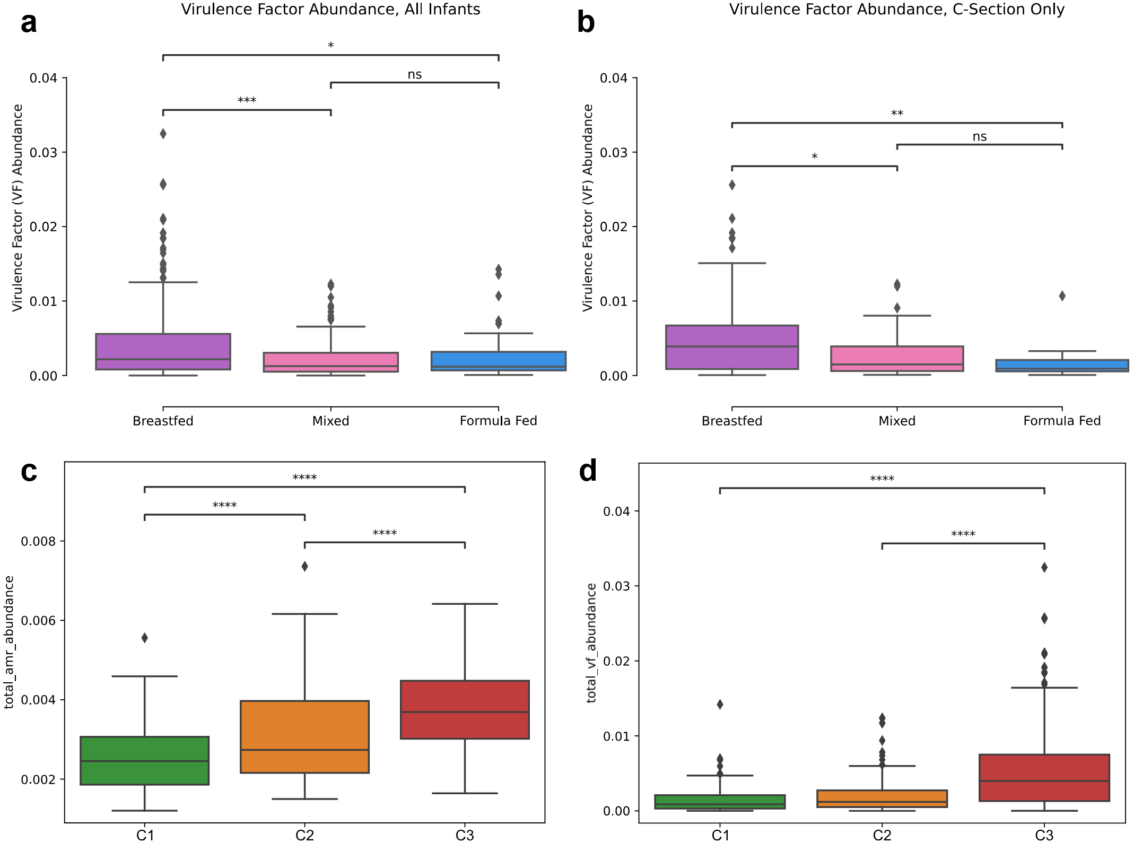
Supplementary Figure 3: Additional Functional Genomic Analysis of Virulence Factors and Antimicrobial Resistance. a. Boxplot of virulence factors in all samples, demonstrating significantly increased abundance in breastfed infants (Kruskal-Wallis *: p < 0.05, **: p < 0.01, ***: p < 0.001, ****: p< 0.0001). b. Boxplot of virulence factors in samples from C-section infants, demonstrating the combined impact of birth mode and feeding method on virulence factor abundance. c. Boxplot demonstrating antimicrobial gene abundance as a function of cluster. d. Boxplot demonstrating virulence factor abundance as a function of cluster.

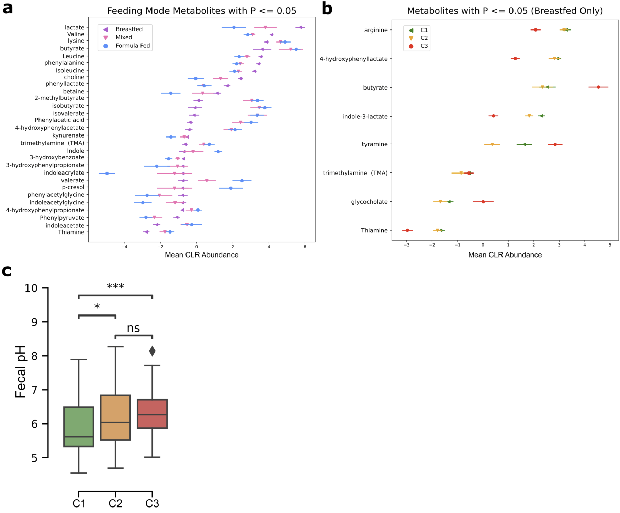
Supplementary Figure 4: Metabolite Analysis. a. Scatterplot displaying the median center log ratio (CLR) abundance and standard error of the mean (SEM) of stool metabolites for each feeding mode (breastfed, mixed, and formula) where there were significant differences among feeding modes (ANOVA test, adjusted p-value <=0.05) b. Scatterplot of metabolites for breastfed-only infants where there are significant differences between clusters (p <= 0.05). c. Boxplot showing stool pH in each DMM cluster (Kruskal-Wallis *: p < 0.05, **: p < 0.01, ***: p < 0.001).

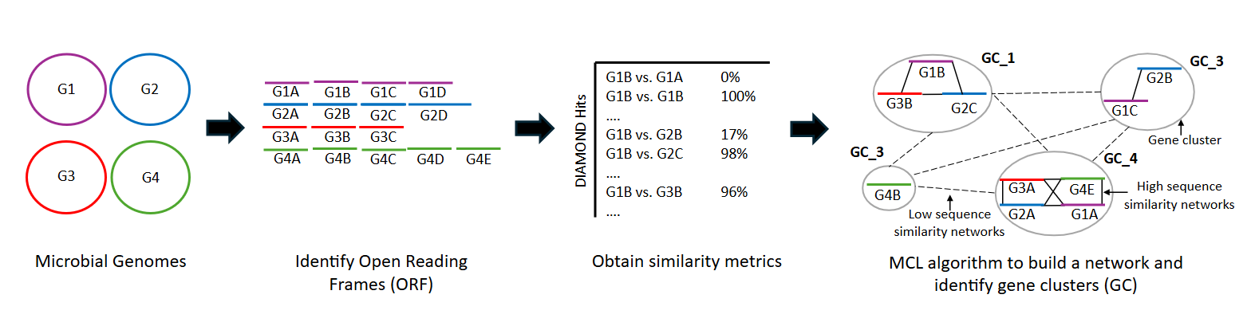
Supplementary Figure 5: Visual representation of Gene Clustering Approach. The computational approach includes the following steps: a. Microbial gene collections (from UHGG, see Methods). b. Identification of open reading frames or potential coding regions within these genomes. c. All-versus-all DIAMOND analysis, querying all genes against a DIAMOND database constructed from those genes. d. Markov Clustering Algorithm (MCL) applied to the DIAMOND output similarity file. This transforms the data into a matrix representing a graph where edges indicate weighted similarities. Higher weights denote closer, more similar genes, while lower weights indicate more distant, less similar ones.

Supplementary Table 4 - Relative risk as a function of Bifidobacterium
Consortia abundance (infantis, breve, bifidum, longum)
Dep. Variable: | adverse_outcomes | No. Observations: | 214
Model: | GEE | No. clusters: | 3
Method: | Generalized | Min. cluster size: | 54
 | Estimating Equations | Max. cluster size: | 92
Family: | Binomial | Mean cluster size: | 71.3
Dependence structure: | Independence | Num. iterations: | 2
Date: | Tue, 29 Apr 2025 | Scale: | 1
Covariance type: | robust | Time: | 23:18:21
 | coef | std err | z | P>|z| | [0.025 | 0.975]
Intercept | -0.5746 | 0.044 | -13.206 | 0 | -0.66 | -0.489
Consortia_Abundance | -0.8549 | 0.227 | -3.76 | 0 | -1.3 | -0.409
B. breve and B. longum alone
Dep. Variable: | adverse_outcomes | No. Observations: | 214
Model: | GEE | No. clusters: | 3
Method: | Generalized | Min. cluster size: | 54
 | Estimating Equations | Max. cluster size: | 92
Family: | Binomial | Mean cluster size: | 71.3
Dependence structure: | Independence | Num. iterations: | 2
Date: | Tue, 29 Apr 2025 | Scale: | 1
Covariance type: | robust | Time: | 23:17:33
 | coef | std err | z | P>|z| | [0.025 | 0.975]
Intercept | -0.6354 | 0.099 | -6.422 | 0 | -0.829 | -0.441
Bifidobacterium_longum | -0.4245 | 0.566 | -0.75 | 0.453 | -1.533 | 0.684
Bifidobacterium_breve | -1.2414 | 0.273 | -4.551 | 0 | -1.776 | -0.707

Supplementary Table 5 – Taxa that were significantly different based on sample collection method

dependent_variable | F-statistic | p-value | mean_ra_pbs | prevalence_pbs | mean_ra_dna_rna | prevalence_dna_rna | adjusted_p_value | significance
Veillonella nakazawae | 0.000031 | 0.000001 | 0.000472 | 3.252033 | 0.005019 | 18.604651 | 0.000654 | ***
Haemophilus_D sp015255025 | 0.000036 | 0.000026 | 0 | 0 | 0.000583 | 4.651163 | 0.002882 | **
Sutterella wadsworthensis | 0.000026 | 0.000013 | 0.00025 | 1.084011 | 0.002779 | 11.627907 | 0.002882 | **
Enterococcus_G italicus | 0.000286 | 0.000024 | 0 | 0 | 0.000793 | 4.651163 | 0.002882 | **
Eisenbergiella sp900550285 | 0.000306 | 0.000024 | 0 | 0 | 0.001921 | 4.651163 | 0.002882 | **
Haemophilus_D parainfluenzae_M | 0.000039 | 0.000033 | 0 | 0 | 0.000366 | 4.651163 | 0.003008 | **
Lachnospira eligens_A | 0.000465 | 0.000044 | 0 | 0 | 0.002182 | 4.651163 | 0.003457 | **
Haemophilus_D parainfluenzae_N | 0.000625 | 0.000052 | 0 | 0 | 0.006268 | 4.651163 | 0.003558 | **
Enterocloster sp900538485 | 0.000208 | 0.000073 | 0.000068 | 0.542005 | 0.002723 | 6.976744 | 0.004437 | **
Clostridium butyricum | 0.000316 | 0.000157 | 0.002118 | 4.065041 | 0.017035 | 16.27907 | 0.008617 | **
Copromonas sp000435795 | 0.01278 | 0.000546 | 0.000043 | 0.271003 | 0.001902 | 4.651163 | 0.02732 | *
Niameybacter stercoravium | 0.00002 | 0.000609 | 0.000094 | 1.084011 | 0.001123 | 6.976744 | 0.02791 | *
Veillonella sp900550175 | 0.001498 | 0.000958 | 0 | 0 | 0.00093 | 2.325581 | 0.033284 | *
Aeromonas caviae | 0.001468 | 0.000989 | 0 | 0 | 0.000347 | 2.325581 | 0.033284 | *
Clostridium saudiense | 0.001371 | 0.001029 | 0 | 0 | 0.000141 | 2.325581 | 0.033284 | *
Anaerosporobacter sp018372435 | 0.001434 | 0.001005 | 0 | 0 | 0.000231 | 2.325581 | 0.033284 | *
Enterobacter cloacae_M | 0.012799 | 0.000813 | 0.000183 | 1.355014 | 0.015246 | 6.976744 | 0.033284 | *
Enterobacter roggenkampii | 0.004728 | 0.00135 | 0.001188 | 2.439024 | 0.002187 | 11.627907 | 0.041249 | *

